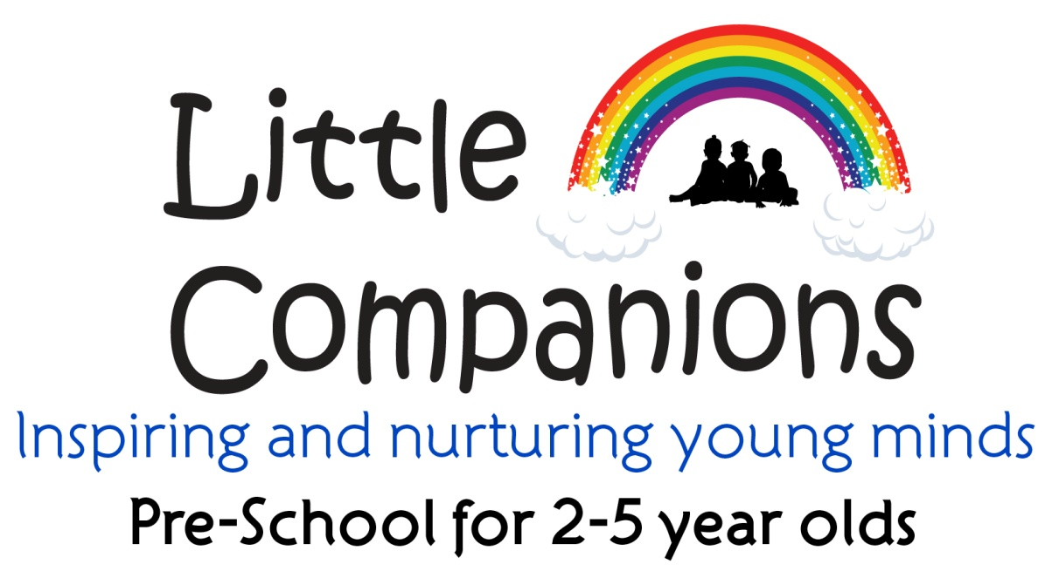

Welcome Pack

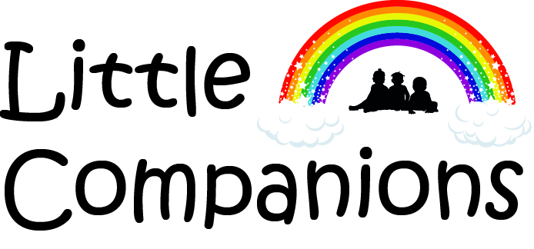
Little Companions- All About me
This form is designed to help us get to know your child prior to starting Little Companions. The information will enable us to help your child settle in smoothly and begin to plan suitable experiences for your child catering to their individual needs and interests.
My Name..................................................................................................................................................
My Age and Date of birth .........................................................................................................................
Positive Relationships
Has your child had experience of playing with other children? How much and where?
Has your child stayed with other people before? How did they react to this? Who did they enjoy spending time with?
Is there certain food your child enjoys/dislikes? Is he/she a good eater?
Does your child enjoy eating independently/eating at a table?
Does your child do the following tasks independently or do they require assistance?

Dressing/undressing – shoes........................ jacket..........................Clothes............................................

Toilet (nappies/toilet trained, special words to indicate need)...............................................................

Eating (alone/with help, cutlery/fingers).................................................................................................

Washing (hands/face)..............................................................................................................................

Who is in your child’s family who your child interacts with regularly? (parents, grandparents, siblings etc)? Please send a photo of your child with his/her family.

Unique Child
What do you feel are your child’s strengths/skills?
Is there anything you would like us to know about your child’s development? (talking, walking etc)
Is there anything you would like us to know about your child’s behaviour/character? ( very happy, shy, sensitive)
What do you do to ease your child when he/she becomes upset or angry? ( give a drink, cuddle, leave to calm down)
What celebrations is your child involved at home? Is there anything special in your culture that we could share in the nursery? ( songs, phrases, landmarks, dress, food)
Does your child having key words in an additional language which he/she may use regularly? ( words for members of the family, water, toilet)
Does your child have any particular fears? (spiders, balloons, particular animals, dirt and so on, how severe?
Does your child have a pet?

Learning and Development
What are your child’s favourite activities? What do they spend time doing? (for example stacking/knocking down, throwing/rolling objects, joining items/ filling and emptying containers, climbing)
Does your child like outdoor play, if so what sort of activities?
What themes is your child interested in? ( for example transport, animals, nature)
Do you read books with your child? Does your child enjoy looking at books? Favourite books? Can they read or recognise words or letters?
Does your child spend time mark making? How? (scribbling/ making shapes/interpreting their marks?)
Does your child communicate confidently? Do they have any favourite nursery rhymes?
Has your child had experience using numbers? Can they count?
The playgroup encourages children to have independent choice of resources and activities. Do you feel your child will have any difficulties in mobility, independence and accessing resources/activities?
The information you have provided will be treated with confidentiality and will only be accessed on a need to know basis by staff in the setting, in particular your child’s key worker. Thank you for your assistance and we look forward to welcoming your child into the setting
Authorised pick up form:

Name of child.................................................................................................................

List of all those authorised for pick up:

.......................................................................................................................................
.......................................................................................................................................
.......................................................................................................................................
.......................................................................................................................................
.......................................................................................................................................
.......................................................................................................................................
.......................................................................................................................................

Please return to the preschool. Thank you.
Please inform us of a password which can be used for the collection of your child when collected by anyone not known to the Preschool :

Dear Parents/Guardians,

Welcome to Little Companions. This pack is full of all the relevant information you and your children need prior to starting. We request that you fill in your child’s ‘All About me’ and authorised persons pick up forms and send them in the stamped addressed envelope enclosed before your child’s starting date at the pre-school or via email. The rest of the details are for you to keep as your reference.

We hope you find this information useful and we look forward to settling your child into their new learning and play environment. Please do not hesitate to contact us should you require any further information.

Kind regards

Naazish Haq and Reema Juttla
Co-Managers

Little Companions’ Team

Managers/Owners:
Naazish Haq BSc(Hons) Molecular Cell Biology, Early Years Professional Status, Cert. Early years Practitioner/ (level 6)/ MA (distinction) Early years education and leadership, Level 5 leadership and management
Reema Juttla BA(Hons) International Business Management, ACCA, Level 3 NVQ Childcare and Development/level 4 leadership and management

Early years Assistants:
Jade Carby (Level 3 Cache- Early years Education)
Nuzhat Ali (Level 3 Cert. Pre-School Practice)
Rehana Shaikh (Level 2- Early years and Child Development)
Nabila Zahoor (Level 3 Diploma- Early years)
Sobia Minar (Level 3- Early years and Child Development)
Hafsa Minar (Level 3 Early Years and Child Development- Apprentice)
Shahina Rajan (Entry level 3 Caring for Children)

Child Protection Co-ordinator:
Reema Juttla and Naazish Haq

First Aiders:
Naazish Haq,
Reema Juttla
Nuzhat Ali
Jade Carby
Rehana Shaikh
Nabila Zahoor
Hafsa Minar
Sobia Minar
Shahina Rajan
Contact Us:
Little Companions
Acorn Hall,
Columbia Avenue,
Eastcote HA4 8UG
W: http://www.littlecompanions.org.uk/

Posting address:
Little Companions
Flat 16, The Thomas More Building, 10 Ickenham Road,
Ruislip, Middlesex, HA4 7BA
T: 07586291510
E: info@littlecompanions.org.uk

Daily Timetable

9.00- Children arrive, parents/guardians sign in and children complete self-registration. Children can hang up their coats and bags and start interacting with the resources in the literacy area until all the children arrive.
9.30- Welcome and circle time. Circle time will allow the children to get to know the topic, as well as communicate about their own interests.
9.45- Free play, children have access to a range of equipment and activities designed to encourage learning and development in all the 7 key areas of the EYFS. The focus activity will also be set out linked to the children’s interests and topic that week, which the children will be encouraged to take part in with the support of the Early Years Practitioners. The children will have access to both the outdoor and indoor areas, and will have an opportunity to independently play and engage with the resources.
10.15-10.45- Snack bar opens consisting of a selection of healthy and nutritious snacks for children to choose and enjoy. The children wash their hands before eating and good meal time etiquette is encouraged. Free- flow play continues with close interaction from the children’s key workers. (3 years + children are engaged in extended play to develop their learning in specific areas, of literacy, mathematics, PALS (play and learning to socialise)
11.10- Children are encouraged to tidy up and get ready for circle which may consist of sound and movement/ story and rhyme.
11.30- Children are ready for pick up/ end of morning session

11.30- Children arrive for the afternoon session/ parents/guardians sign in and children complete self-registration. Children can hang up their coats and bags and start interacting with the resources.
11.50- Children start toilets, washing hands and get ready for lunch time.
12.00- Lunch time, this is a social occasion. The children will have support from practitioners with independent eating encouraged. Good meal time etiquettes are encouraged.
12.30- End of lunch time/ Morning children staying on who require a nap, will be taken to the enclosed quiet area for some wind down and sleep time. The rest of the children can interact in free play. The focus activity will also be set out linked to the children’s interests and topic that week, which the children will be encouraged to take part in with the support of the Early Years Practitioners. The children will have access to both the outdoor and indoor areas, and will have an opportunity to independently play and engage with the resources.
1.15- Children are encouraged to tidy up and prepare for some physical play, sound and movement, followed by winding down- ( group play/ focused listening and attention activities are incorporated )
1.40- Winding down and quiet time, followed by story time.
2.00- Children are ready for pick up. ( Monday – Wednesday, children can stay till 3.00)

*please note there is an element of flexibility within the daily routine due to the nature of child led interests in the EYFS/ or any events and specialised activities held at the preschool

All About Little Companions

Curriculum Information: At Little Companions the curriculum provided to the children follows the Early Years Foundation stage (EYFS). We work in establishing the EYFS in a warm and stimulating environment catering for the children’s individual needs. Within the seven key areas practitioners will provide a holistic approach to learning so children can appreciate their sense of belonging and identity. Please find enclosed in the welcome pack some information providing further details about the EYFS curriculum. Our key practitioners are all graduates with many experiences such as varied languages, experience in providing support for those with English as an additional language, all which will be incorporated when planning a balanced learning environment using both the indoor and outdoor areas. We will send weekly newsletter to inform parents/guardians of specialised experiences to be provided each week and other activities and notices we would like to share as parent partnership is paramount to the EYFS curriculum.

Settling-in: Each child will go through a settling-in period in order to ease them into the playgroup routine, during this time we will work closely with parents to achieve a smooth transition for each child into the playgroup environment. Settling-in period may vary according to each child’s individual needs and abilities. We may recommend in some cases that parents/guardians bring their child to an extra session in the week to ease settling. They will not be charged for the extra session during the settling period. Parents/guardians will be encouraged to leave their child at the playgroup, gradually extending the time left on each session until the child is confident to stay. Parents can call the pre-school for any updates on their child and the practitioners will be available for any assistance they may require. Should a home visit be required to support settling this will be decided between the parent/carers and key worker and a convenient time arranged for the manager and key worker to visit the home.
Payment Structure: Fees are paid on a monthly basis at the beginning of each month. The amount will be calculated according to number of sessions each week and parents/guardians will be notified by the preschool when fees are due and methods of payment. For those eligible for the 2- or 3-year-old funding we would require you to bring in your birth certificate for us to view during the first week and we will require you to fill in the forms when you come. Please note any information filled in are kept confidential as required under the Data protection act and only shared with the relevant funding bodies when requested. We are also now required to see your child's red book so please do bring that in with you during the first week. Funding starts the term after the children turn 3 years old and we apply on your behalf.

Parking: Car parking facility is available; however we request that parents/guardians are courteous to our neighbours and park with consideration not blocking any driveways.

Safe arrival and departure: For picking and dropping your child, parents will be required to ring the bell at the entrance. On ringing the bell a practitioner will let you in and receive your child. There will be a signing in and out book which parents/guardians must fill in on entry and exit to the nursery. If parents/guardians are dropping and going, then a practitioner will do signing in on their behalf. When parents leave the premises please do let a member of the team so know so the door can be locked on exit.
Safeguarding and welfare: If your child has hurt themselves at home and may show a significant graze or bruise please do inform a practitioner on arrival and you will be required to fill in a form. This is important regarding the welfare of the child, and ensuring the right care is given (for example if any dressings need to be changed) as well make practitioners aware that a child has not been hurt in the setting. We also request that mobile phones are not used inside the setting or at pick up or drop off.
Outdoor play: Our outdoor area is part of the holistic learning environment and children have supervised times when they can free flow inside and outside for both structured and child initiated play. The play can involve elements of forest schooling and risk play and this is SUPERVISED, with sufficient interaction and engagement. Children are supported through this type of play. During outdoor play, the front gate is locked and only opened if there is a visitor who is escorted indoors and once the children are all inside and outdoor play is finished. The ratio is maintained during outdoor play, with 2 - 3 practitioners outside and 2 inside. Practitioners ensure relevant risk assessments and headcounts are carried out prior to, during and after outdoor play.
Complaints: If you have any complaints or concerns please do arrange to meet with the manager/child’s key worker. Appointments can be requested via your child’s diary which practitioners will check daily or by calling the preschool. Any formal complaints will be notified to Ofsted and dealt within the stipulated 28 days. The number to call Ofsted with regards to a complaint is: 0300 123 4666
Water Bottles: At Little Companions we feel it is important that every child can independently access clean drinking water when they feel the need. Therefore, we request that parents/guardians bring a water bottle filled with fresh water on a daily basis. Our staff will refill the water bottle when necessary, during the day and return the bottle to the parent /guardian at the end of the child’s session to be taken home for cleaning.
Snack: Snack bar is opened during the morning session at 10.00am -10.40am and in the afternoon session at 1.30pm-1.45pm. Our snack menu consists of a variety of healthy and nutritious snacks with seasonal fruits and vegetables. The menu for each day will be displayed for parents/guardians to view. In the afternoon session should a child require lunch, parents/guardians can send in a packed lunch which we can serve at snack time. The packed lunch must in line with our healthy eating policy and we request parents/guardians do not include crisps, sweets, chocolates and fizzy drinks. We have the facility to warm food and request that this is provided in clearly labelled microwaveable containers.
Children’s Electronic feedback: We will use weekly individual brief emails sharing information about your child’s development and interests. We will record each day what your child has enjoyed in their session and ask that you fill us in on all that your child has been doing at home, this may include, places they have visited, achievements, new vocabulary and latest interests. You can send emails with any comments or questions you have for your child’s key worker. Parents are welcome to speak to their child’s key worker at pick and drop off or can arrange an appointment for any longer meetings. Key workers will keep parents informed of their child’s progress and there will be regular progress meetings held. The individual emails are in addition to general weekly newsletters and also the sharing of photos of key experiences.
Nappy changing and potty training: We do not expect your child to be potty trained on starting the playgroup and when your child is ready to be trained, we will support you in this process to make the transition from nappy to toilet a happy one. We have a potty training policy and recommend that you read that when your little one is ready for training. For those still in nappies we require a labelled bag with nappies, wipes and nappy sacks to be brought to preschool every day.

The following is a checklist of items which your child needs in preschool in each session; all items must be clearly labelled:
- Water bottle
- Bag containing spare change of clothes
- Nappies/wipes/nappy sacks
- Please send the children in appropriate and comfortable clothes for the weather. In the autumn to spring months, the children will require Wellington boots for their outside play.

*Please note that due to these unprecedented times of Covid-19, some changes to policies in particular to the settling guidance, pick up and drop off may be put into place and these will be shared with parents via email accordingly*
For more in-depth policies and procedures and term dates please do visit our website:
http://www.littlecompanions.org.uk/
---------------------------------------------------------------------------------------------------------------------------------------
The Early Years Foundation Stage. What does it mean?
The Early Years Foundation Stage (EYFS) is a document for early years providers, to help them support your children’s learning and development from birth to five years old. This year the Government made changes to the revised EYFS introduced on 1 September 2012 all early years and as of September 2021 some further changes have been made to the EYFS development matters curricula.
Who makes sure that registered early years providers are following the EYFS?
All registered early years providers are inspected by Ofsted to make sure they meet the legal requirements of the EYFS. We are also provided support from the Local Early years’ advisory team, who also visit to ensure standards are being met. OUR OFSTED REPORT CAN BE FOUND AT THE FOLLOWING LINK http://www.ofsted.gov.uk/inspection-reports/find-inspection-report/provider/CARE/EY462146

What are the main changes in the revised EYFS 2012 and 2021?
The revised EYFS builds on the good practice of the original 2008 EYFS and still has a playbased approach to children’s care, learning and development. The revised EYFS is designed to:
- have less paperwork
- give early years providers more time to plan around the needs of your child
- support your child through planned, challenging, enjoyable and playful experiences and opportunities.
- Children will no longer be assessed against statements from an age band category. Instead, staff will use their experience and knowledge to monitor if a child’s learning and development is on track for their age.
- The early learning goals at the end of reception have been changed to become more clear and easier to understand. Staff will use their judgements to assess if the children have met these goals at the end of the EYFS and inform parents and carers.
- There is an emphasis on improving children’s language and vocabulary through increasing opportunities for conversations, reading of a wide range of books and holding discussions around activities in other areas of learning.
- Literacy and numeracy skills focused on in the EYFS have been adapted to better match up with the national curriculum that starts in year 1.
- There is no longer an exceeding judgement at the end of reception. Children will instead be challenged to have a greater depth and understanding of ideas.
- Safeguarding and welfare of children is still a priority, with the added mention of teaching children about the importance of good oral health and how to keep teeth clean and healthy.

The revised EYFS reminds your early years provider how important it is to have a good relationship with you. And it recognises that you need to be given more information about your child’s learning and development. The requirements for your child’s safeguarding and welfare have also been revised.

What do you mean by safeguarding and welfare requirements?
To explain, here are a few of the EYFS Safeguarding and Welfare statutory requirements (2012) that early years providers need to put in place to keep your child safe. Early years providers must update their policies and procedures to make sure that if your child is in their care, then they are protected. These include:
- They must have a policy on the use of cameras and mobile phones.
- There must be training and supervision for all staff to make sure that they fully understand their roles and responsibilities.
- They must keep full records of how to keep and give medicines and who is trained to do this.
- They must have strict data protection and a system to protect confidential information.
- They should have a named person for the management of behaviour.
- Safeguarding and welfare of children is still a priority, with the added mention of teaching children about the importance of good oral health and how to keep teeth clean and healthy. (2021 addition)

What else does the EYFS do?
The EYFS also sets out what all early years providers must do to make sure that your child learns and develops. It promotes teaching and learning to make sure all children have the skills to get them ready to progress through school and future life. Early years providers must make sure that their staff are fully aware of what they have to do, to make sure your child’s individual needs are met through the EYFS.

Who will make sure my child’s learning and care is tailored to them? Your child will be assigned a key person when they start with an early years provider. You will be told the name of the key person and their role. The key person is there to make sure that your child’s learning and care is tailored to meet their individual needs, through discussion with you. They will also support you in giving you ideas on what learning you can do at home with your child.

What will my early years provider be doing with my child?
Your early years providers must think about the individual needs, interests and stages of development of each child in their care. Early years providers working with children from birth to three years old, will be expected to focus on the following three prime areas, which support learning in all other areas.
Personal, social and emotional development:
- Building relationships
- Managing self
- Self-regulation
Physical development:
- Gross motor skills
- Fine motor skills
Communication and language:
- Listening, attention and understanding
- Speaking

These three prime areas help children to develop and learn, and become ready for school. As well as the three prime areas, early years providers will also plan activities in the following areas of learning and development, known as specific areas.
Literacy:
- comprehension
- word reading
- writing
Mathematics:
- number
- numerical patterns
Understanding the world:
- people, culture and communities
- the natural world
- past and present
Expressive arts and design:
- creating with materials
- being imaginative and expressive

The learning experience will be enabled with the 3 ‘characteristics of effective learning’ :
- playing and exploring - children investigate and experience things, and ‘have a go’;
- active learning - children concentrate and keep on trying if they encounter difficulties, and enjoy achievements; and
- creating and thinking critically - children have and develop their own ideas, make links between ideas, and develop strategies for doing things
How will I know how my child is progressing within the EYFS requirements? Assessment helps you find out about your child’s progress, understand their needs and plan their activities. Your child will have two important assessments before the end of the EYFS. The first when they are between two and three years old and the second in the final term of the year in which your child reaches the age of five. Ongoing assessment is also an important part of this. Your child’s early years provider will look, listen and note how your child plays and then build on this by planning a challenging environment to support your child’s development. You can also share what you see your child doing with your child’s key person.
What if I am worried about my child’s development?
If you’re worried about your child’s progress, talk to you early years provider and together you can agree how to support your child. If your child’s home language is not English, their early years provider must give them opportunities to develop and use their home language in play and learning to support their language development at home. Your early years provider must also make sure your child has enough opportunities to learn and reach a good standard in English language during the EYFS.
How can I find out more?
Talk to your child’s key person who will be happy to answer any questions you have. You can also view a copy of the Statutory and non-statutory Framework for the Early Years Foundation Stage 2021 on the Department for Education Development Matters 2021

